Georgia Association on Higher Education and Disability
Formerly, Georgia Association of Disability Service Providers in Higher Education

Georgia AHEAD
CONNECTIONS

SPRING 2006 ASSOCIATION NEWSLETTER

Message from the President

Dear GA-AHEAD Members and all Disability Service Providers,

This has been quite a busy year for GA-AHEAD. The Spring Conference Committee has been working all year to develop an affordable and informative first Southeast Regional Conference. The results are outstanding! Denise Johnson Marshall, the Conference Chair from Georgia Tech, Dr. Elaine Manglitz, the Program Co-Chairman from Clayton State University, and Rebecca Story from Highlands College, provide previews on what to expect in this newsletter. Don’t miss the opportunity to attend this conference---take a look at what is planned and who will be here! If you have not been to the city of Decatur in a while (or never) you are in for a treat.

Wayne Akins, the President Elect from Georgia Southern University, and I visited with most of the regions to explore state and regional needs. We obtained a list of priorities the membership would like addressed by GA-AHEAD and developed a survey that was sent to each postsecondary institution in the state to help gauge the top priorities of the membership. If you have not completed the survey, please take a few minutes and complete it and send to me (www.ga-ahead.org). All questions do not have to be answered; we are mainly concerned about your needs. There is more focus on regional meetings and a reorganization has been completed to make contact and travel reasonable. Wayne accomplished this daunting task and details the results in this newsletter.

The GA-AHEAD Board is working with the E-Text Committee to support passage of the House Bill 898: Postsecondary E-Text Legislation. Several states have passed legislation to impact textbook publishers to provide alternative text for access. Most of you know about the Alternative Media Access Center (AMAC) developed at the Regents Center for Learning Disorders at UGA. We all experience difficulties providing appropriate alternative text for students with print disabilities. Solutions provided by AMAC are needed state-wide and we believe passage of this bill will enhance its ability as well as each institution’s to provide adequate accommodations. Cooperation from publishers is tantamount for our successful service provision.

Dr. Christopher Lee, the Director of AMAC developed some questions we added to the GA-AHEAD survey. AMAC plans to provide services to all postsecondary institutions, not only those under the auspices of the BOR. Again, if you have not completed this survey, please take a few minutes to do so---responses are needed to show need to the Board of Regents, DTAE, the state legislators, and so on. Also, legislative support for the bill is tenuous due to a lack of understanding. We need each of you to contact Representative Bill Hembree (this week!) to explain our need in this area and to encourage him to introduce the bill. His address is:
The Honorable Bill Hembree
State Capital, Room 417
Atlanta, GA 30334

In January of this year, the Vocational Rehabilitation Program of the Georgia Department of Labor signed a cooperative agreement with BOR and DTAE. The State ADA Office will be the liaison between VR and postsecondary institutions for collaboration. The GA-AHEAD board has been active in the discussion and planning of the agreement. Improved understanding and enhanced services are expected. More detail will be posted on the GA-AHEAD website in the near future.

Networking, collaboration, education and support is what we are about. Be active in your region and let us know how GA-AHEAD best can work for you.

I hope to see you all at the conference!

Bonnie Martin
President, GA-AHEAD
bmartin@gpc.edu

Spring Conference Features & Registration - Denise Johnson Marshall,

Georgia Tech

Greetings Georgia AHEAD,
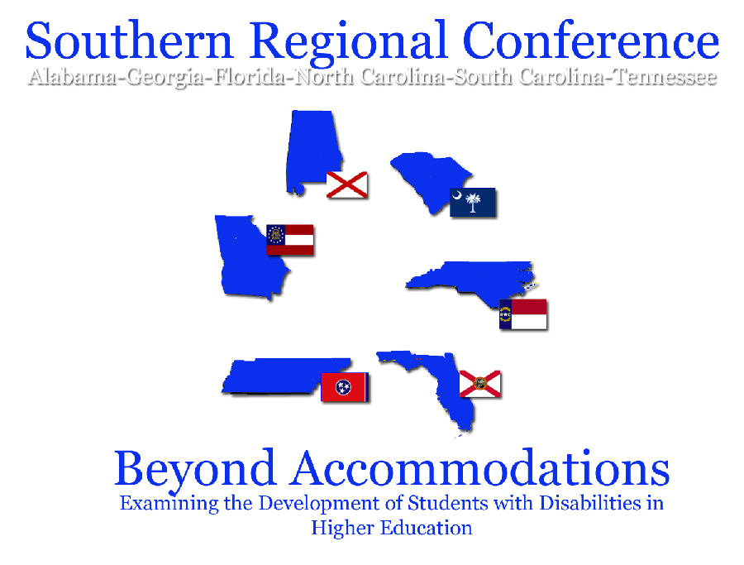
On behalf of the 2006 Georgia AHEAD Southern Regional conference committee, we would like to say welcome to "Beyond Accommodations: Examining the development of students with disabilities in higher education."

“Beyond Accommodations” conference will examine how students with disabilities adapt to campus life while dealing with issues in study abroad, classroom interactions, distance learning, housing community standards, student code of conduct, social adjustment, student developmental and communication skills.

We will also look into ways that we as disability service providers, can impact the development of students by teaching student responsibility and self-advocacy skills.

We hope that this year's conference will prove to be a great opportunity for networking and sharing information and resources. We have received a record number of programs and we are excited to have Salome Heyward with us this year along with the president of AHEAD, Jim Kessler.

Our conference will include our traditional events such as the silent auction, vendor showcase, two pre-conferences and officer elections. We are also pleased to bring back the resource fair as well.

This year will feature our colleagues from TN, NC, AL, SC and FL.
Please join us as we enjoy the sights and sounds of Atlanta/Decatur March 29-31, 2006 where we will begin with your choice of two great pre-conferences and a welcome reception. Help us greet our out of town guests along with the local deans and vice-presidents in the Atlanta-Metro and neighboring areas. For more information check out our website at: http://www.ga-ahead.org/spring2006conf.html

Take advantage of registration rates before March 10, 2006 for best value. Final deadline for registration March 17, 2006.
-Denise Johnson Marshall
Georgia AHEAD
2006 Conference Chair
denise.johnson@vpss.gatech.edu

Conference Program – Elaine Manglitz, Clayton State College

You are in for a treat when you attend the Southern Regional Conference at the Holiday Inn in Decatur, GA on March 29-31, 2006. We had a record number of high quality conference proposals this year. The proposals came not just from Georgia but from several of the other states who will be joining us this year – Alabama, Tennessee, South Carolina, and North Carolina. We received at least one proposal from each of these states and in most cases, more than one!

The concurrent sessions represent a wide range of topics that address the conference theme, “Beyond Accommodations: Examining the Development of Students with Disabilities in Higher Education.” Concurrent session topics include those that address program development through assessment, collaboration with other campus departments, the “millennial” students and their parents, using student interns in the disability service office, vocational instructor training in accessible learning, and many more. In addition and true to the theme of the conference, several sessions will include information on student development, working with students to implement viable student organizations, student involvement in improving access to information technology, and student learning outcomes.
Conference Program
As you can see from this general and partial listing of program topics, the conference will offer a variety of sessions to meet the needs and interests of those of us who work with students with disabilities in the postsecondary environment! For additional information on the Southern Regional Conference, including information on registration and hotel accommodations, please go to the Georgia AHEAD web site at www.ga-ahead.org.
We hope to see you there!
Let the bidding begin!
GAAHEAD is holding a silent auction to raise funds for our student evaluation award. Both organizations and individuals are invited to contribute to the Silent Auction.
We need you to participate by providing merchandise for the Silent Auction

Please email Rebecca Story rstory@highlands.edu with a description and suggested value of your item before the Conference.
By contacting me in advance I will have the time to organize and categorize the items prior to the Conference.
Bring your item with you to the Conference.
Silent Auction item suggestions: (all contributions are welcome)
- Articles that are representative of your region.
- Basket of regional foods, like wine, special sauces, seasonings, recipe books, etc.
- College or University or Tech school items (t-shirts, sweatshirts, etc.)
- Patriotic memorabilia
- Collectibles (figurines, etc.)
- Fine Art pieces
- International arts and crafts
- Autographed picture, CD, book, or photograph by a well known person
- Books by faculty authors (signed even better)
- Books relevant to postsecondary disability support services (signed even better)
- Disability related software
- Vacation rentals or tours
- Services (massages, day spa, etc.)
Silent Auction-continued
What a great way to represent your school!
Thank you members, exhibitors, and others in advance for your generous donations!
PS. I have it on good authority that Rodney’s wife has been busy this year, and has made another beautiful afghan!

Resource Fair

Do you have a great publication that you worked hours on?

Let’s save others some our valued time!
Why reinvent the wheel?


Note Taker Request Form
Interpreter Request
Reader Request
Testing Room Reservation
Policy Forms
Mid Term Grade Assessment Forms

Anything and everything!

Send the electronic format of your documents to rstory@highlands.edu
These will be complied and up for viewing at the March 2006 conference.
After the conference they will be available on the website for your convenience!

Let’s Rip off and Replicate all of our hard work!

rstory@highlands.edu

University/College/Technical School Profile – Rebecca Cowen-Story, Georgia Highlands College

Good Day Colleagues! This is Rebecca Story from Georgia Highlands College, the NW GA regional representative. I would like to introduce you to a freshman member of the GA-AHEAD family, Shelia Parker. Shelia Parker has been a member of GA-AHEAD since March of 2005. Shelia joins our organization as the representative from Coosa Valley Technical College in Rome, Georgia. At Coosa Valley Technical College, where she has devoted the last 10 years, Sheila has her hands in many areas around campus; she is the lead sign language interpreter for the school. She also coordinates all part-time interpreters that they require.
Along with these duties Shelia works on special population projects for the Vice President of Instruction. Shelia holds an Associate’s degree in Human Services, a Bachelor’s in Organizational Management, and in currently pursuing her Master’s in Rehabilitation Counseling. In her spare time Shelia enjoys organizing youth events at her church (due to three teenage sons), and drinking hot black coffee. Shelia is also affiliated with GA Registry of Interpreters of the Deaf and the national Registry of InterpretersRID as well. Please join me in encouraging Shelia in her membership with GA-AHEAD. We all need to lend a hand now and then. Shelia can be contacted at sparker@coosavalleytech.edu .

Georgia AHEAD Regions Realigned – Wayne Akins, Georgia Southern University

As an initial part of Georgia AHEAD’s emphasis on improving communications from the Board to members, a motion was approved at the last board meeting to realign regions. Our goal is to streamline information going out via region reps and to make the regions more geographically sensible. Hopefully, there is a central spot in each region that’s no more than an hour’s drive for everyone.
The new alignment adds an Atlanta region, grouping all of the Metro schools into a single region. It reduces the Central region and slightly enlarges the Coastal region. The Southwest region is unchanged, and the Northeast and Northwest regions lost some schools to the new Atlanta region.
As we head into our state conference and hold elections for offices, please keep in mind that we will need a region chair for the Atlanta area. If you have interest in becoming more active in Georgia AHEAD, talk with me in March about the regional rep position.
Our Southwest region chair will need replacing also, so you members down in that area can be thinking about a good person to represent you on the Board.
Here’s what the new regions look like – See Ya in March!

Georgia AHEAD Region Realignment

Northwest Region (9 schools)

School City

Appalachian Tech Jasper

Dalton State Dalton

Georgia Highlands Rome

Berry College Rome

Covenant College Lookout Mountain

Reinhart college Canton

Shorter College Rome

Coosa Valley Tech Rome

Northwestern Tech Rock Springs

Northeast Region (15 schools)

School City

Augusta State Augusta

North Georgia College Dahlonega

Gainesville College Gainesville

Medical College of Georgia Augusta

Athens Tech Athens

Augusta Tech Augusta

Lanier Tech Gainesville

Brenau Gainesville

Emmanuel College Franklin Springs
Northeast Region - continued

School City

Paine College Augusta

Peidmont College Cornelia

Toccoa Falls College Toccoa

Truett-McConnell Cleveland

Young Harris Young Harris

North Georgia Tech Clarkesville

Central Region ( 20 schools)

School City

Columbus State Columbus

Fort Valley State Fort Valley

Georgia College and State University Milledgeville

Georgia Southwestern Americus

Gordon College Barnesville

Macon State Macon

Middle Georgia College Cochran

Central Georgia Tech Macon

Columbus Tech Columbus

East Central Tech Fitzgerald

Flint River Tech Thomaston

Griffin Tech Griffin
Central Region - continued

School City

Middle Georgia Tech Warner Robins

South Georgia Tech Americus

West Central Tech Waco

West Georgia Tech LaGrange

Georgia Military College Milledgeville

Lagrange College Lagrange

Mercer University Macon

Wesleyan Macon

Coastal Region ( 15 Schools )

School City

East Georgia College Swainsboro

Heart of Georgia Tech Dublin

Swainsboro Tech Swainsboro

Armstrong Atlantic Savannah

Coastal Georgia Community College Brunswick

Georgia Southern Statesboro

Savannah State Savannah

Waycross College Waycross

Altamaha Tech Jesup

Ogeechee Tech Statesboro

Coastal Region -continued

School City

Okefenokee Tech Waycross

Savannah Tech Savannah

Southeastern Tech Vidalia

Brewton Parker Mount Vernon

Savannah College of Art and Design Savannah

*Atlanta Region (28 schools)

School City

Clayton State Morrow

Georgia Perimeter Lawrenceville

Gwinnett University Center Lawrenceville

DeKalb Tech Clarkston

Gwinnett Tech Lawrenceville

Agnes Scott Atlanta

Atlanta Metropolitan Austell

Georgia Tech Atlanta

Georgia State Atlanta

Kennesaw State Marietta

Southern Polytech Marietta

West Georgia College Carrollton

Atlanta Tech Atlanta

Atlanta Region - continued

School City

Chattahoochee Tech Marietta

North Metro Tech Austell

Atlanta Christian Atlanta

Atlanta College of Art Atlanta

Art Institute of Atlanta Atlanta

Bauder College Atlanta

Clark Atlanta Atlanta

Emory Atlanta

Life University Marietta

Morehouse Atlanta

Morris Brown Atlanta

Oglethorpe Atlanta

Oxford Atlanta

Spellman Atlanta

St. Andrew Atlanta

Southwest Region (13 schools)

School City

Abraham Baldwin Tifton

Albany State Albany

Bainbridge College Bainbridge

Darton College Albany

South Georgia College Douglas

Valdosta State Valdosta

Albany Tech Albany

East Central Tech Fitzgerald

Moultrie Tech Moultrie

Southwest Georgia Tech Thomasville

Valdosta Tech Valdosta

Andrew College Cuthbert

Thomas College Thomasville

Diversity Career Symposium

Sponsored by:
The Office of Disability Services
Division of Student Services
New Student Center
Suite 230
www.gsu.edu/disability
404-463-9044

The symposium will focus on the advantages of hiring people with disabilities, transition to work, employment readiness and success.
Jump start your career with:
Informational workshops
Networking opportunities
Career and related resources
CD of pre-scanned resumes provided for all participating employers

Date: 03/28/2006

Time: 10:00—3:00 pm

Registration 9:15 am - Noon
Georgia State University - House Ballroom - Student Center

This event is free but reserve your space early: www.gsu.edu/disability



Making Your Event Accessible to People with Disabilities,
Rodney E. Pennamon, Georgia State University
It's doubtful that any event planner would intentionally make his/her meetings, resources, and events inaccessible to potential participants. However, some practices result in that outcome for individuals with disabilities that impact their sight, hearing, and/or mobility. Even for planners who want to assure that their offerings are accessible, it is not always clear what specific accessibility issues should be considered when planning events, publications, web resources, and other activities. Where do you start? As increasing numbers of people with disabilities participate in academic opportunities, careers, families, and community activities, the accessibility of all organizations increases in importance. The goal is simply equal access; every member or potential member of your organization should feel welcome and be able to use your resources and participate in sponsored activities.

The DO-IT Center (Disabilities, Opportunities, Internetworking and Technology) at the University of Washington promotes the success of individuals with disabilities in postsecondary studies and careers, using technology as an empowering tool. One of its publications, Equal Access: Universal Design of Professional Organizations
www.washington.edu/doit/Brochures/Programs/equal_access_udpo.html
provides a checklist of suggestions for making your organization accessible to everyone. The checklist promotes "universal design", whereby, rather than planning for the average user, you design for people with a broad range of characteristics with respect to ability, disability, age, gender, and race/ethnicity. Checklist questions can be edited to make them specifically relevant to your organization. Below, under some of the broad areas of access addressed in the publication, are overall guidelines and examples of checklist items. The publication includes guidance and resources for addressing issues raised by specific questions.

Planning and Evaluation. Consider diversity issues as you plan and evaluate services. Example:
- Are people with disabilities included in the organization's planning process?

Information Resources. Assure that publications and websites welcome a diverse group of prospective members; assure that the content in publications and websites is accessible to people with a variety of disabilities. Examples:
- Do pictures in your publications and website include people with diverse characteristics with respect to race/ethnicity, gender, age, and disability?
- Do electronic resources, including web pages, adhere to accessibility guidelines or standards?

Facilities. Assure physical access, comfort, and safety. Example:
- Are there ample high-contrast, large-print directional signs to and throughout the facility, indicating accessible routes?
Staff and Volunteers. Make sure staff and volunteers are prepared to work with all members and participants. Example:
- Do all staff members and volunteers know how to respond to requests for disability-related accommodations, such as sign language interpreters?
This publication also includes presentation, exhibit and other communication hints. Consult the DO-IT website www.washington.edu/doit for other resources that can help you develop publications, websites, and activities that are accessible to everyone.

Rodney E. Pennamon
DO-IT/Access College Team Member

